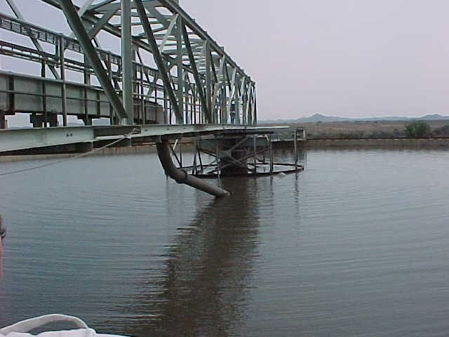
PROCESS PLANT SPECIALISTS
On Point Mining Solutions
Engineered for Performance. Built for Process Reliability.
About Company
Our core values — integrity, collaboration and innovation — guide us in achieving long-term success and building lasting relationships.
At On Point Mining Solutions, our clients are at the centre of everything we do. We understand that every operation faces unique challenges, and we are committed to listening to our clients' needs, addressing their concerns, and delivering practical, cost-effective solutions that create measurable value. Through our expertise in the design, fabrication, repair, upgrading, and servicing of process plants and equipment, we help mining operations improve reliability, reduce downtime, enhance plant performance, and extend equipment life. Our goal is to build long-term partnerships by providing responsive service, technical excellence, and solutions that contribute directly to our clients' productivity, profitability, and operational success.
Andy and Phillip Wehmeyer have owned or been partners in Heavy Engineering, Machining and Fabrication Facilities since the early 1980’s, having worked closely with large companies such as Envirotech (which became Baker Hughes and then later FL Smidth), Svedala, ELB and Metso to name a few. Fabricating, Site assembling and assisting with Commissioning of Process equipment such as Thickeners, Flotation Cells, Flocculant Plants, Linear Screens etc.
Also Fabricated for DRA and Batemans as well as numerous mining companies such as Impala Platinum Group, PMC and Foskor among others.
More recently they were partners in and then later managed the Fabrication division of MIP Process Technologies for over 10 years.
The brothers have been involved in the fabrication of Process Plants for over 40 years and between them have more than 80 years’ experience in this Industry.
Through our strategically located fabrication facilities and trusted fabrication partners in both Gauteng and KwaZulu-Natal (KZN), we are able to provide efficient manufacturing capacity, reduced lead times, and responsive support to clients across South Africa and neighbouring regions. From precision machining and fabrication through to site installation, maintenance, and commissioning, our team is committed to delivering quality workmanship, reliable performance, and cost-effective solutions tailored to each client's operational requirements.
What You Gain
Reliable Workmanship
Reliable workmanship is the foundation of everything we do. Operating from fully compliant fabrication facilities and supported by qualified, experienced personnel, we are committed to delivering high-quality fabrication, repairs, and plant maintenance services that meet industry standards. Our focus on precision, quality control, and professional execution ensures dependable results, giving our clients confidence that every project is completed safely, efficiently, and to the highest standard.
Minimum Downtime
Through planned, proactive site audits, scheduled service shutdowns, and rapid access to essential spares and fabricated replacement components, we help identify and address potential issues before they result in costly failures. This proactive approach minimizes equipment standing time, reduces unplanned downtime, and ensures your process plant continues operating at optimal performance.
A Real Partnership
At On Point Mining Solutions, we believe successful projects are built on strong relationships. Our focused and interactive team takes the time to understand not only your process plant and operational requirements, but also the people who run it every day. By working closely with your team, we develop practical, tailored solutions that align with your objectives, creating a true partnership built on trust, collaboration, and shared success.
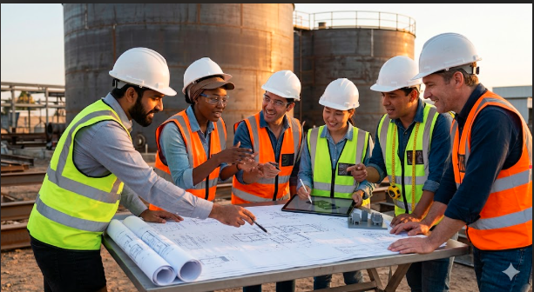
Our Team
Our team comprises experienced professionals who bring expertise and passion to every project. Through continuous improvement and strategic partnerships, we strive to remain at the forefront of our sector — driving growth and creating value for all stakeholders.
With a vision focused on sustainability and community impact, we are devoted to responsible business practices and making a positive difference in the areas we serve.
Have a project to scope?
Tell us about your plant — we'll come back with a straight answer.

